Regent London Recommended Hotels

Wilde Aparthotel Covent Garden

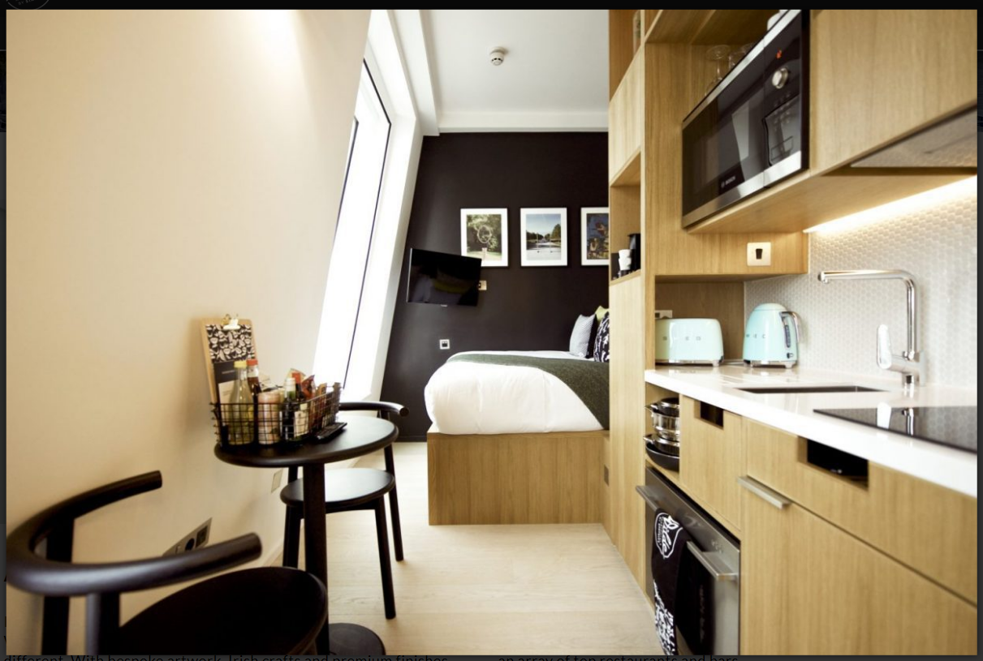

This is very close to the school (a few minutes walk). It has apartments but with a 24 hour reception. It has nice design features and some rooms have mini-kitchens.

https://www.staycity.com/wilde/london/covent-garden

Strand Palace Hotel

This grand, traditional city hotel is just a short walk from Regent London (5 mins)
It includes a gym, business centre, restaurant and bars.

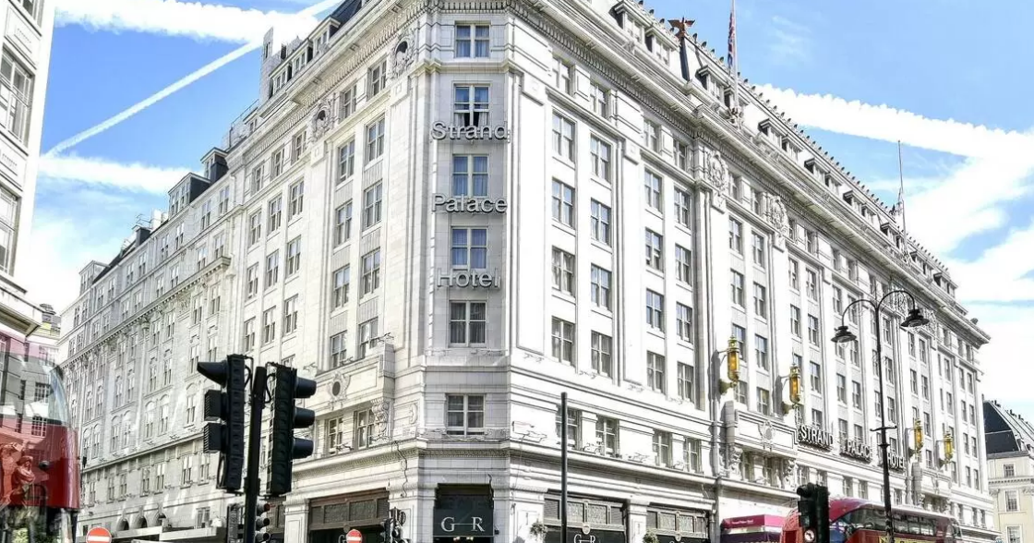

https://www.strandpalacehotel.co.uk/

