Regent London recommended residences

Kings Cross Residence

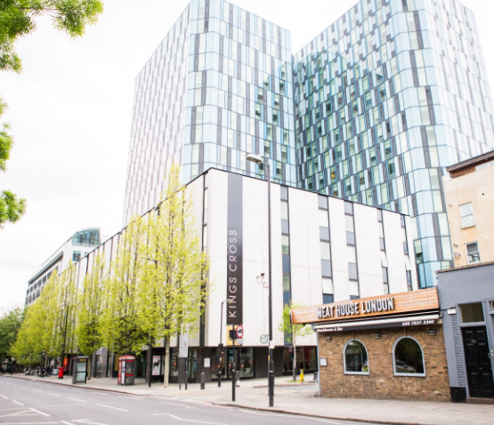

Located in Zone 1 with great transport links, this large, modern residence has a friendly and vibrant atmosphere. It has several communal areas for studying and socialising and an On-site 24-hour gym open to all residents.
https://www.londonist.co.uk/residences/kings-cross-residence_7

Spitalfields Residence
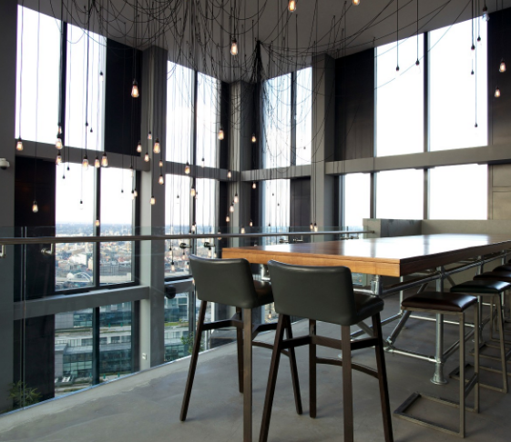
Also located in Zone 1 in a lively, trendy part of the city, this tall, modern residence includes a games room, 24-hour onsite gym and various communal areas for socialising and studying.

https://www.londonist.co.uk/residences/spitalfields-residence_10?

